Saved search which shows customers internal ids and their points earned.

Points earned: custom field

Run a conversion so, 2 points it’s a dollar.

On creation of invoices and credit memos -> a user event will execute and we get the amount of points (ask zinrelo).
Then, we have 2 points for a dollar,
Then from there, create a journal entry (Transactions -> Financial -> Make Journal Entry) and we set on lines:
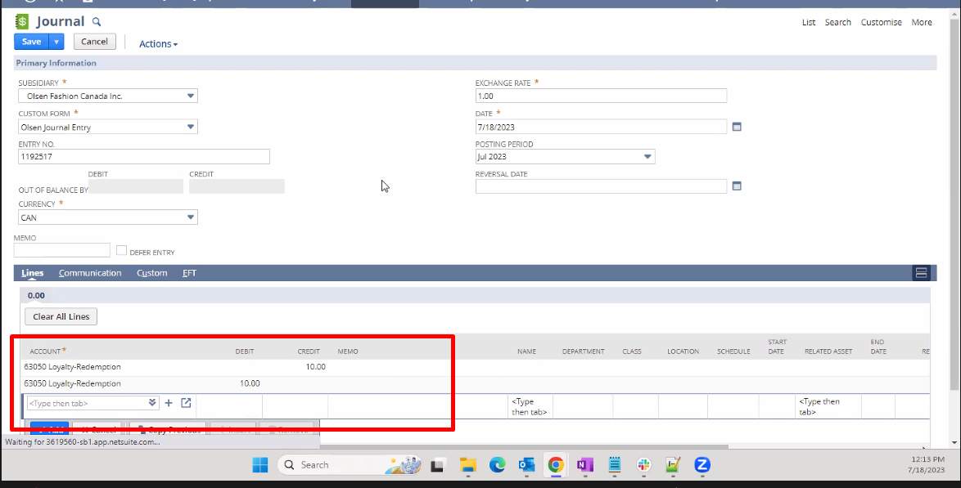
Loyalty-Redemption credit: figure out to which account we credit (ask zinrelo)
Loyalty-Redemption debit: figure out to which account we debit (ask zinrelo)

Then we impact the GL: to do that we create a journal entry Transactions -> Financial -> Make Journal Entry

